FullSync Synchronization Core
Architecture

Proposal

[2005-06-14]

Table of Contents

Table of Contents 2
Introduction 3
The Abstract Synchronization Core 4
Phase States 5
Phase Communication 5
Phase Logic 6
The File Synchronization Core 8
Things to solve 8
Classes used in File Synchronization 9
FileSyncInputElement extends Element 9
FileSyncElement extends Element 9
Rule Provider 9
Filter 10
Traveler 10
TaskGenerator/ActionDecider/ActionGenerator 10
TaskDecider 10
TaskExecutor 10

Introduction

The synchronization core is the heart of FullSync’s internal processes. Although the main GUI version of FullSync is designed for synchronizing files the underlying synchronization core should be as abstract as possible. A more concrete implementation will be the file synchronization core which is currently the only focused implementation. Another use case is the synchronization of sql tables (using specific required fields like id and date).

Main goals of this architecture are flexible creation of synchronization processes, good feedback, many interaction possibilities and robust error handling.

The Abstract Synchronization Core

Regardless of the domain in which a synchronization should take place, they are always processes that can easily be divided into phases. Thus the core consists of an abstract representation of processes with phases which are processing elements.
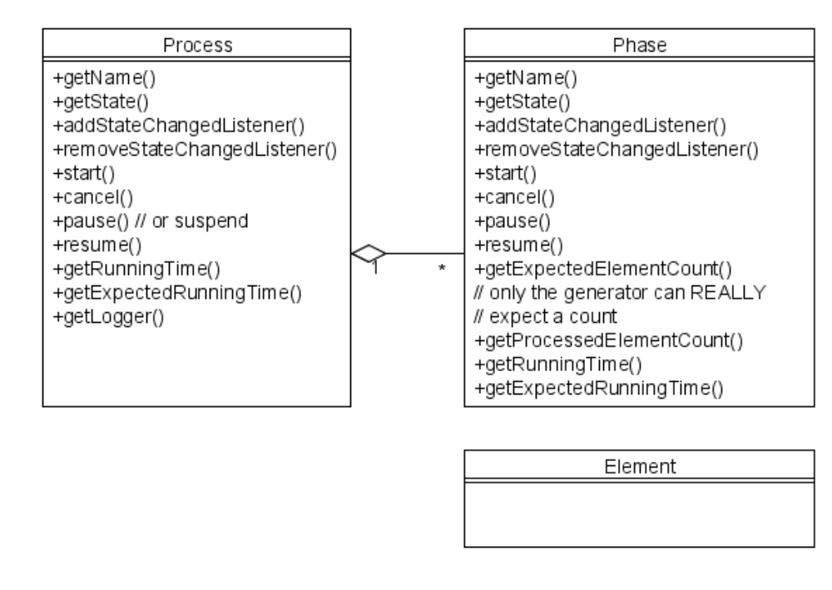

All processes must explicitly be started and can then be cancelled, paused and resumed. For identifying their current state, they provide a state property and change listeners for this property. This functionality is distributed to the phases. So each phase can also be started, cancelled, paused and resumed, and also provides its current state with a change listener. For statistical reasons the phases need to know about how many elements they expect and how many they already processed. Using this data they can estimate the time needed to perform all elements.

The phases should be able to run each after another or in stream mode, say each element enters the next phase as soon as it is finished in the current phase. Additionally the phases should be able to run simultaneously, having a thread for each phase and queues between them.

Phase States
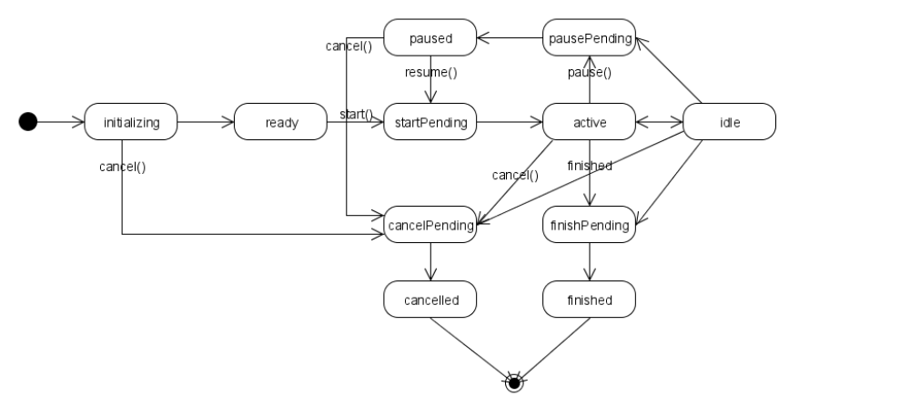
Pending states represent execution of transition code needed to enter the desired phase. In single threaded mode this will be executed instantly, in multi threaded mode it will be executed when the thread is ready to perform the transition.

Phase Communication
Requirements:
- Elements need to be transported from one phase to the next using a mechanism which works in single and multithreaded mode
- Information about the first and last element must be provided

Elements are passed through the phases using the elementProcessed event. Each phase is a elementProcessed listener and provider for in and output, respectively.
Inline phases handle the event within the same thread. Threaded phases need to queue incoming elements within the event handler method. (fulfills 1.)

Additionally we could introduce elementProcessingStarted and elementProcessingFinished event methods. (fulfills 2.)

Comments:
- Is the started method really needed? Is it thrown when the first element is processed or when processing started? In the second case, this would be too early to use this event to start the next phase. (does it really matter when a phase is set ready/idle?)
- An argument against some kind of blocking architecture for multithreaded execution is that it makes it hard to change the status to idle.

Phase Logic
Because the main execution logic of a phase should not depend on the execution mode (single-thread-per-phase, single-thread-per-process) it is useful to implement the PhaseLogic interface and just define the main loop and the activities that must be executed to reach certain states.
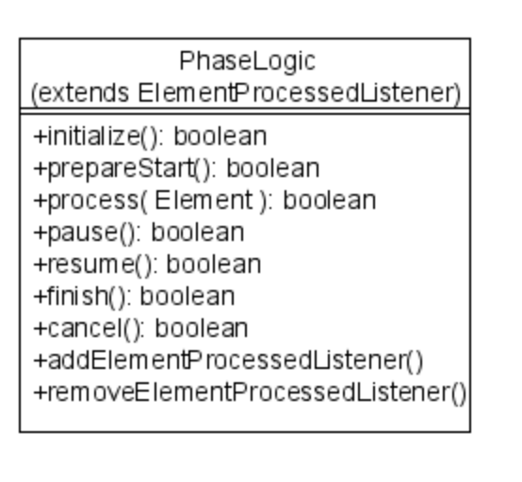

All methods must return true if they finished execution and false if they cease execution because of being interrupted. In the latter case the element that was given to process() will not be removed from the queue and a second call to process() will occur using the same element.

Comments:
- Another idea would be to make some kind of PhaseController pulling the controlling logic from the Phase and then using the phase itself for the main logic?

Comments on the Abstract Synchronization Core
- Only the generating phase can really EXPECT how many elements will come,
all other phases have to rely on their previous phase (but do they know their previous phase?)
- Naming: Pause or suspend? pause
- Is an explicit stop method needed/useful? no
- Should elements already built up a tree structure? For example database entries are plain. No+, but maybe they need to know their sync process? No, but they may know internal elements (like the input element)
- We need elementProcessed() event handlers (this might be the connection to the next phase and provides feedback to gui things) -> ok
- If elementProcessed() is not used to transfer elements from one phase to another (keep in mind that there may be queues between them), we need another mechanism to do that (emit(Element) and process(Element))
- States need “~Pending” values as well, these are especially needed by the processes (as they express that some phases are not cancelled yet)
- Is multithreaded execution that useful? It works anyways
- Streamlike behavior destroys the atomic change, but reduces memory load a lot and might even speed up the whole process
- Is good error handling provided here already? We might emit ErrorElements and SuccessElements in the end.
- Is it good to extend from phase or should it wrap the main logic? As the main logic just needs process() (and it would make multithreading way more easy).
maybe find a general wrapper and give the main logic an interface too. -> PhaseLogic

- At first we will not try implementing all the stuff, I think single-threaded stream-like (new one) and block-like (as it is now) will be enough

- Actually there are semantic differences between the first phase (producer), middle phases (modifiers) and the last phase (consumer).
-> not if we have one initial input element and emit error/success elements in the end.

The File Synchronization Core

Things to solve
- New traversal types:
some synchronizations only need the source to find out changes, so why bothering the destination as long as we don’t need it
thus traversal types represent the way the synchronized hierarchy is generated, only look for files in source, in dst or both.
what happens with files only on dst when we traverse src only?
- Stream-like behavior (done by sync core) for non interactive syncs
- Cancel/Pause/Resume (done by sync core)
- Better reporting (done by sync core)
- Bin/ascii (filesystem?)
- Case sensitivity (filesystem?)
- Check canRead/canWrite before executing task (in actionDecider?)
- Capabilities of filesystems (“can set last modified”) (?)
- Filesystem.isAvailable checks
- Source and destination buffers work differently
- Permissions, user, group
- Symbolic links ? (not really supported by java)
- File type: file, dir, notexisting (say imaginary like it’s called in VFS)
- File.isFiltered() (done by Traveler)
- Filter needs a location, source filter, dst filter, both sides filter
- Lock profiles when executed (just connect profile with running process or null)
- Explain in logs why a file was synced, not synced or ignored
- Refresh of buffer works pretty tricky
- Write to tmp file and rename (.syncfiles and all files in backup syncs)
- Correct file size shown in taskdecision (depending on the actions direction)

- Use VFS as FS layer and build something for buffering atop
- Always use absolute file lookups (so we don’t depend on a parent when finding files enabling us to have an incomplete file hierarchy

- The streamlike behavior now prevents us from changing the execution order according to the taken action. For example dirs may only be deleted when their content is deleted first.

Classes used in File Synchronization
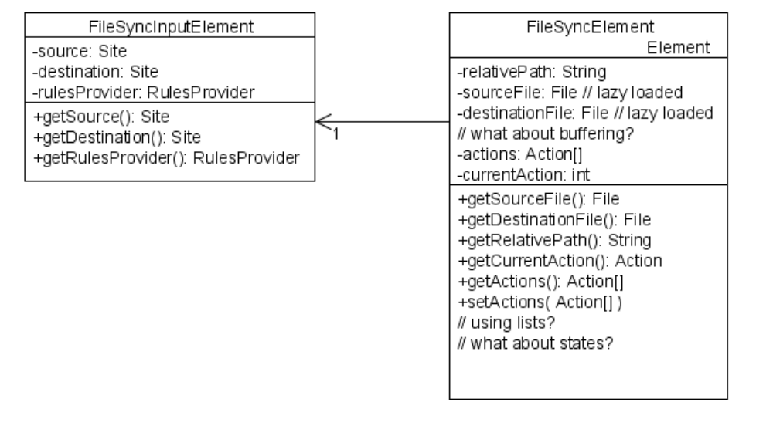

FileSyncInputElement extends Element
This is the initial input to a file synchronization process. It contains the source and destination sites and the rulesProvider.

FileSyncElement extends Element

This class represents an element of the file synchronization process. Each element represents a pair of source and destination file, the available actions that can/should be performed and the currently selected action. The semantics of the actions is well known.

Comments:
- What about state?

Rule Provider
The Rule Provider is responsible for providing rules depending on the path of a given file/path. Although it will be referred to as one object it might well be a composite of multiple rule providers with different priorities and overwrite rules.

Filter
Shouldn’t a filter be applied to the Site that is being scanned?
No, as you can define filters which will have impact on the other site too.

Traveler
The first phase in file synchronization needs to traverse a file system and build up a list of synchronization elements. This is done by the traveler. It also handles file filtering and rule provider updating.

There are three most important traveler types: source-only, destination-only and source-and-destination. Only the last one will build up a complete hierarchy containing all elements of both sides, but it is also the most expensive traveler.

Comments:
- Rule provider updating is thought to give the rule provider the chance to update itself using data in the current directory. It does not change the rule provider except adding new rules to the directory. The rule provider does not know in which directory/context he is called, he always expects absolute paths (absolute to the sync root).
- Another way would be appending the rules to the FileSyncElements

TaskGenerator/ActionDecider/ActionGenerator
The ActionGenerator is responsible for defining the possible actions for a given FileSyncElement and set the default action. To do that he can use the rule provider, state decider and buffer state decider.

ActionDeciders (used by the action generator) are a subject to be defined in xml.

TaskDecider
The TaskDecider can modify the current action of the tasks and give feedback to the user.

TaskExecutor
Executes the tasks.

Comments:
- Who handles write to tmpfile and then rename? The FileSystem or the TaskExecutor?

